Jonathan Ashdown

07930 535 494
jonathan.ashdown@gmail.com
28 Barnett Close, Leatherhead, KT22 7DW
Full clean driving licence with extensive experience driving abroad.
www.jonathanashdown.com

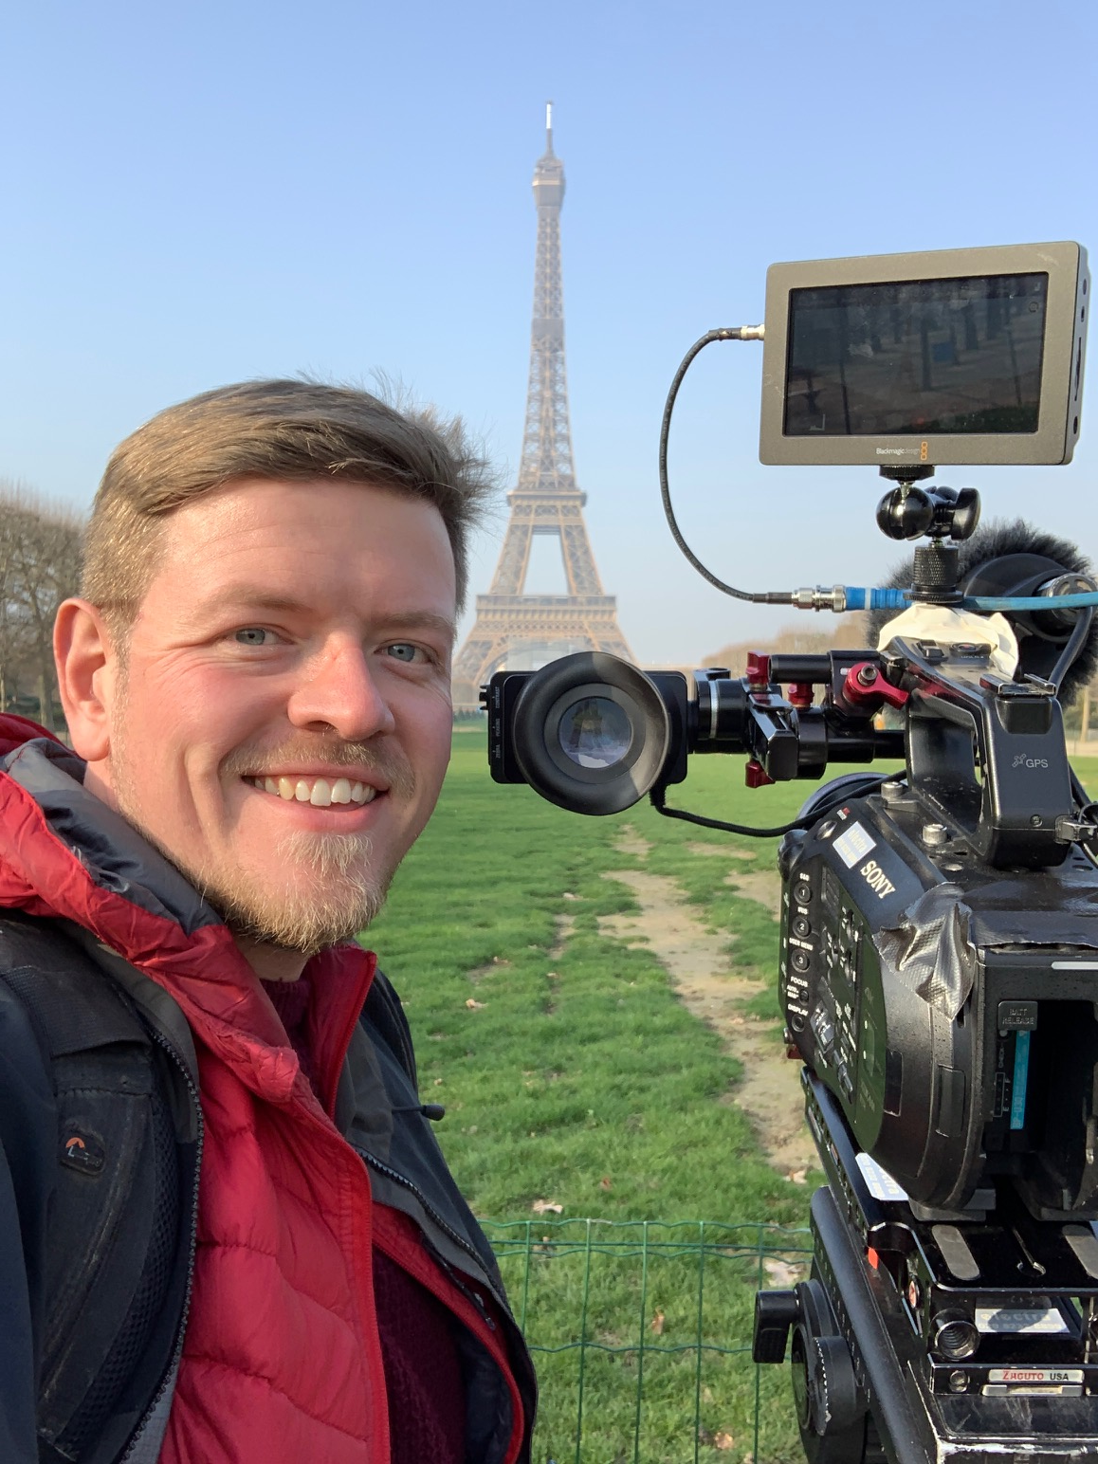
For the past 10 years I have worked as a camera assistant and camera operator, working on productions for all major British broadcasters including the BBC, ITV, Channel 4, Netflix and Amazon. I am diligent, professional and friendly with a strong eye for detail. I am an excellent communicator, always punctual and I am also used to working flexibly across early mornings, late nights and weekends.I am comfortable working in extreme conditions and have experience working in -30 degrees in Kasakhstan, sailing across the Indian Ocean, or even pushing Freddy Flintoff’s VW camervan up a high mountin pass in Peru with a Land Rover. Working on Top Gear has given me a lot of experience driving abroad, sometimes on some of the worlds most dangerous roads. I love my job.

Camera Operator
Brian Cox Life the Universe and Everything, BBC, 2021 DoP Toby Wilkinson, Dir Simon Winchcombe
Top Gear (Digital) - BBC, 2021 DoP Ben Cornish/Jonathan Ashdown, Dir Stephanie Fox
Rob and Romesh Vs Series 4, CPL Productions 2021, DoP Toby Wilkinson, Dir Graham Proud
Rob and Romesh Vs Series 3, CPL Productions 2020, DoP Toby Wilkinson, Dir Graham Proud
Extinction The Facts featuring David Attenborough, BBC, 2020, DoP Toby Wilkinson Dir Serina Davies
(Second camera/jib op/assistant)
Rob and Romesh Vs Series 2, CPL Productions 2019, DoP Toby Wilkinson, Dir Graham Proud
The Great Travel Hack Series 2 London to Istanbul, 2019, DoP Dan DeCastro, Dir Ben Duncan
Rob and Romesh Meet, CPL Productions 2018, DoP Barney Wilkinson
Babies Netflix/Nutopia 2018 DoP Toby Wilkinson Dir Rebecca Kent
Siblings Short Film 2017, Dir Stephen Gallagher

BBC Top Gear
Series 31 BBC Dir John Richards, Toby Wilkinson, Iain May, Jay Kennedy, Toby Wilkinson, Arri Amira
Series 30 BBC Dir John Richards, Toby Wilkinson, Iain May, Matt Wright, Casper Leaver, Arri Amira
Series 29 BBC Dir John Richards, Toby Wilkinson, Iain May, Matt Wright, Casper Leaver, Arri Amira
Series 28 BBC Dir John Richards, Toby Wilkinson, Iain May, Matt Wright, Steve Lidgerwood, Arri Amira
Series 27 BBC Dir John Richards, Toby Wilkinson, Iain May, Matt Wright, Casper Leaver, Arri Amira
Series 26 BBC, Dir Mark McQueen, Dan DeCastro, Iain May, Matt Wright, Toby Wilkinson, Sony F55.
Series 25 BBC, Dir Mark McQueen, Dan DeCastro, Iain May, Matt Wright, Toby Wilkinson, Sony F55.
Series 24 BBC, Dir Mark McQueen, Dan DeCastro, Iain May, Matt Wright, Toby Wilkinson, Sony F55.
Series 23 BBC, Dir Mark McQueen, Dan DeCastro, Iain May, Matt Wright, Toby Wilkinson, Sony F55.

Factual/Entertainment/Travel
Rob & Romesh, CPL, Toby Wilkinson, Arri Amira (Junior Camera Op)
The Big Flower Fight, Multistory Media, Mark McQueen, Dan DeCastro, F55
Babies - Netflix, Toby Wilkinson, Rebecca Kent, Sony F55 (Second Camera Operator)
W Series - Whisper Films, Ben Joiner, Chris Omand, Sony F55
Gordon, Gino & Fred Road Trip - Studio Ramsey, DOP Roger Laxon, Sony F55
A League of Their Own - CPL, DOP Iain May, Dir Brian Klein, F55 (Assistant/Junior camera Operator)
Strictly the Best – BBC, DOP Roger Laxon, Sony F55 (Camera Operator)
Rob & Romesh Meet Shania Twain – CPL, DOP Casper Leaver, Sony F55
Rob & Romesh Meet Anthony Joshua – CPL, DOP Toby Wilkinson, Arri Amira (Assistant/Junior Camera Operator)
Wonderful World Of Babies - Voltage TV, DOP Toby Wilkinson, Arri Amira (Assistant/ Junior Operator)
Babies - nutopia, DOP Duane McClunie, Sony F55
Grand Prix Driver - Amazon, DOPs Jamie Kennedy & Robin Fox, Arri Amira
Ducks Quacks Don’t Echo - Magnum TV, DOP Phil Piotrowsky, Sony F800
The Naked Choir - Twenty Twenty, DOP Matt Wright, Sony F800
Secret Files - BBC, DOP Jeremy Hewson, Arri Amira
Raising Pompeii - TwoFour, DOP Paul Lang, C300
The Grand Tour – Amazon, DOP Casper Leaver, Arri Amira (Dailies)

Comedy/Drama Productions
This Time With Alan Partridge – Baby Cow, DOP Pete Rowe, Sony F800
Zapped - Baby Cow, DOP Pete Rowe, Arri Amira.
Tracy Ullman Sketch Show - BBC, DOP Pete Rowe, Arri Amira
Keith and Paddy Sketch Show - Talkback, DOP Pete Rowe, Arri Amira
Hoff The Record - Me + You, DOP Duncan Telford, Arri Amira
Cuckoo S2 - Roughcut, DOP Jamie Cairney, Arri Alexa.
People Just Do Nothing S1 - Roughcut, DOP Jamie Cairney, Arri Alexa.

Commercials/Digital Content
Fish4Dogs TVC - Velvet TV, Matt Wright, Sony F55
Hammond & May Shell promo – Chimp Productions, Toby Wilkinson, Arri Amira
Jaguar Land Rover - Foxtrot Papa, Toby Wilkinson, Sony F55
Jaguar Promo - FP Creative, Jay Kennedy, Sony F55
Guide Dogs Commercial - Arthur + Martha, Claudio Cadman, C300 Mkii
Mini Commercial - The Outfit, Simon Rowles, Arri Amira
Asos - Short Form Film, Paul Mackay, Arri Amira
Centre Point - Short Form Film, Sy Turnball, Arri Amira
Jaguar Promo - FP Creative, Steve Albins, Sony F55
Davina McCall Fitness DVD - QVC Links, Iain May, Sony F800
Top Gear Live Promo - TG Live, Chris Dunford, Sony F55
BP - Stuart Biddlecombe, Arri Alexa

- Extensive filming abroad.
- Extensive rigging experience for adhoc vehicle to vehicle camera tracking.
- Experience on a wide variety of shoots from comedy/drama to multi-camera and corporate productions.
- Familiar with various formats including Arri Alexa/Mini, Arri Amira, Sony F55, Sony FS7, Sony F800, Blackmagic Ursa Mini Pro, Red Ranger, Sony A7s II, Sony PMW200, Canon C300 mkii, Canon C300, Canon 5Dmkiii, Canon XF105, Panasonic Varicam, Panasonic GH4, Panasonic 3700, GoPro’s
- BA (hons) Film & Television Production – University of Leeds (York St John)
- Trained in house for 3 years at Electra Film & TV focusing on the maintenance and up keep of broadcast equipment both in the kit room and on location.
- Proficient in the set up and use of ABC and Speedy cranes as well as experience in erecting and assisting Jimmy Jib cranes, dollies, track and lighting equipment.
- Full clean driving licence and vast experience driving abroad.
- Other interests include distance running & Leicester City Football Club.

References available on request.

